Name: Akshat Prakash Srivastava

Branch & Year: CSE 2nd Year

Roll no.: 2300290100029

Domain: Data Analysis

Project Report

Project 1:

Difficulty: Easy Module: Get started building with Power BI

Project: Simple Power BI Report

Description: Creating a basic report in Power BI using sample data.

Report:

In Power BI, a **report** is a multi-page, interactive document that displays data visualizations and insights from one or more datasets.

* Made 4 reports to display the data corresponding to various departments:
  + Customer Report
  + Product Report
  + Store Report
  + Sales Report

* Used the knowledge and Power BI tools to create a basic report using various data visualizations options available in Power BI such as Cards, Maps, Graphs etc to display various data sets of the report
* Customer Report:
  + Map displays the locations of customers worldwide via their State and Continent
  + Line and Stacked Column Chart to represent the number of customers in each City and State
  + Donut Chart to mark the educational qualifications and occupations of the customers
  + Pie Chart to represent Gender and Marital Status of the customers

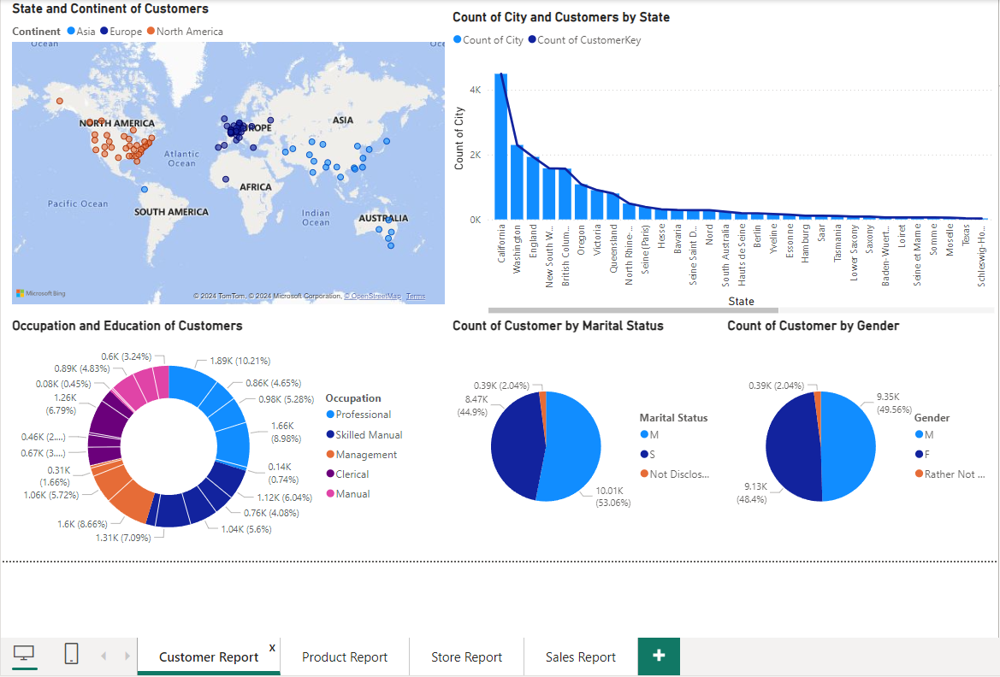

* Product Report:
  + Pie Chart to display the no. of products by each Manufacturer/Brands
  + Table to display the products, their brands and unit cost and unit price
  + Column Chart to provide details about availability of products quarterly
  + Column Chart and Table to display product details such as Product Category and Sub-Category

* Store Report:
  + Map displaying Stores by State and Continent
  + Pie Chart showing Stores and their Selling Area
  + Donut Chart showing Employee Numbers of each Store
  + Line Graph to represent Count of Stores by State

* Sales Report:
  + Slicer to display Sales details of product via their ProductKey
  + Quantity of Products Sold using a Column Chart
  + Clustered Column Chart to show Customer and their purchases of Products
  + Card Visuals to display Unit Cost, Unit Price, Discount & Net Price of the Sales
  + Pie Chart showing Stores making the most Sales
  + Table showing Order (Month and Year) and Delivery Date (Month and Year) of Product

Skills Developed:

* Hands-on experience of Power BI workspace
* Loading Data to Power BI
* Using various Data Visualization options and techniques in Power BI

Project 2:

Difficulty: Medium Module: Create Dashboards in Power BI

Project: Dashboard Development

Description: Create a comprehensive Dashboard using Power BI

Report:

In Power BI, a **dashboard** is a single-page, high-level view of key metrics and visuals from one or more reports or datasets. Unlike a report, which can span multiple pages, a dashboard provides a snapshot with selected visuals that are pinned to highlight critical data points.

Key Features incorporated in the Dashboard:

1. Sales Data consisting of Product Unit Cost, Unit Price, Discount, Net Price and Profit via Cards.
2. Individual Product Sale details like Quantity of product sold and category via Graph to understand Market requirements
3. Profit generated through each Product via Graph to find most profitable assets
4. Top 50 Customer Purchases to understand which customers are biggest market
5. Store Employee details to keep track of manpower

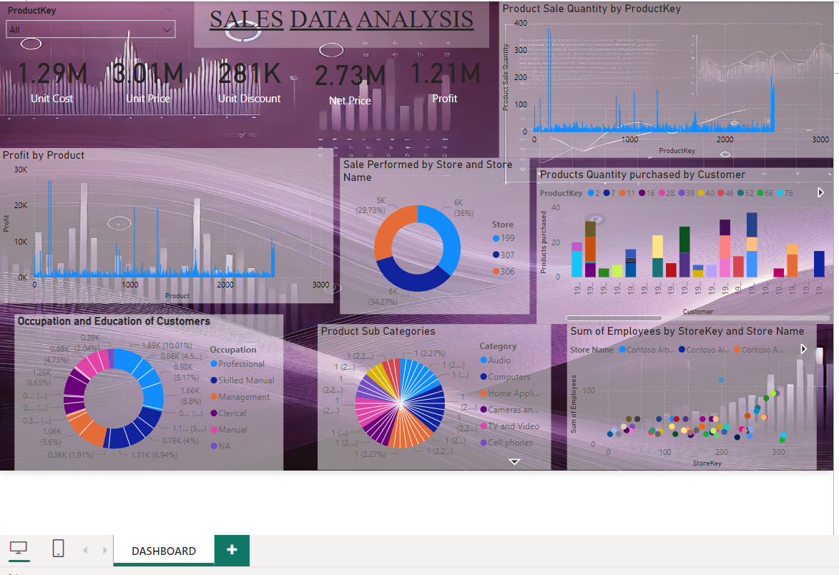

Skills Developed:

1. Experience with Power BI workspace
2. Loading and Transforming Data using Power Query
3. Dashboard Design
4. Difference between Dashboards and Reports